School Improvement Teams
Guidance relating to the Education Accountability Act
Rhode Island Department of Education
Fall 2020

This document provides local education agency and school leaders in Rhode Island with an overview of the revised duties and composition of school improvement teams per state legislative updates to the Education Accountability Act.

Table of Contents

Introduction 2
Legislative context and requirements for school improvement teams 3
Background 3
Legislative requirements for school improvement team composition 3
Duties of school improvement teams 5
Impact on principals and other education leaders 6
Special considerations for school improvement team collaboration 6
Summary 12
Appendix 13

Introduction
A school improvement team (SIT) is a group of educators and other stakeholders who in partnership with the school’s leadership, inform important governance decisions with a focus on improving student outcomes (see Box 1 for this definition and definitions of other key terms). Although the composition of a SIT may vary from school to school, Rhode Island state law provides some clarity on the roles that must be included.
SITs play a crucial role in promoting a holistic integration of school operations necessary to support school change. Specifically, experts suggest that teams can serve as key change agents in school improvement, which is grounded in the theory of action that those in a school who are closest to students know the needs of students best and therefore are best positioned to make and implement recommendations for improvement. This concept of distributing leadership to include multiple staff members leading strands of the work across a school can facilitate implementation of initiatives and reforms by increasing buy-in among key actors and stakeholders. SITs are designed to allow stakeholders to collaborate to better understand school problems and assess needs, set priorities for improvement, and recommend opportunities for change. Including a diverse group representative of the broader community on SITs, stakeholders can incorporate unique perspectives and experiences into improvement strategies.
Box 1. Key Terms
The following terms are used throughout this guidance and are defined here as a reference.
- School improvement team (SIT): A group of educators and other stakeholders who consult with and assist the school principal in making important governance decisions and/or leading and coordinating school-improvement initiatives.
- Distributed leadership: A purposeful alignment of practices designed to enlist stakeholders as leaders in pursuit of a shared vision.
- District action plan: An annual plan that describes the specific activities, persons responsible, and timelines for action to be taken as part of the strategic initiatives set forth in the districts three year improvement plan, and identify the staff and financial resources allocated to support these activities.
- District three year improvement plan: A comprehensive, three year plan that includes an analysis of student and subgroup achievement gaps in core subjects, identifies specific improvement objectives and the strategic initiatives used to address them, how the effect of the initiatives will be evaluated, and the professional development activities that will support the initiatives.
- State assessment success plan: A plan submitted annually to RIDE by districts where more than twenty percent (20%) of students do not meet grade level expectations of at least proficient or its equivalent state assessments.
- School improvement plan: An annual plan that documents goals, strategies, and action items to lead to improved student achievement outcomes.
- Curriculum accommodation plan: A plan that assists regular classroom teachers in analyzing and accommodating diverse learning styles of all children and in providing appropriate services and support.

Legislative context and requirements for school improvement teams
This section presents the legislative context for the state’s focus on school improvement teams (SITs), as well as the legislative requirements for SIT composition and duties.

Background
The Rhode Island School Improvement Team Act formally mandated the establishment of SITs in every public school in Rhode Island in 2000. The Education Accountability Act of 2019 (S0865) amended the Rhode Island School Improvement Team Act to expand the duties of principals and SITs in order to shift toward greater school-based management at the school level (see Table A1 in the appendix for an overview of how the SIT duties have shifted). Before this bill was enacted, if SITs existed, the procedures and functions of the SITs were largely decided on by the school committee and principal, and the SITs were only mandated to evaluate school improvement plans. Under the Education Accountability Act of 2019, SITs have a more prevalent role in school decisions. In addition to the formulation of a school improvement plan, the team is tasked with the following:
- making recommendations to the principal for the development, implementation, and assessment of a curriculum accommodation plan;
- assisting in the identification of the educational needs of students;
- assisting in the preparation of the annual budget; and
- making recommendations for the hiring of personnel.
The law grants SITs many authorities, outlined in box 2, but prohibits interfering with the rights of teachers and other school employees to collectively bargain. Additionally, SITs do not have the authority to interfere with school operations or abrogate any agreement reached by collective bargaining. It is important to note that some SIT duties articulated by the law may be in conflict with local collective bargaining agreements. When this is the case, parties should revisit collective bargaining agreements to seek mutually agreeable language that aligns with the law’s requirements.

Legislative requirements for school improvement team composition
Per Rhode Island legislation, school committees are required to establish a SIT for each school in the local education agency, and shall develop procedures for the election and appointment of SIT members. Members representing teachers, education support employees, students, and parents are selected by their peer groups at the school, in a fair and equitable manner. Business and other community members are selected by the school according to a procedure established by the school committee. The school committee reviews the membership composition of each SIT. If it is found that the membership is not representative of the ethnic, racial, and economic communities served by the school, the school committee will appoint additional members to achieve proper representation.
Key Actions:
- The school committee develops and adopts a policy for the election and appointment of SIT members.
- The superintendent (or designee) operationalizes and communicates the procedures for the election and appointment of SIT members.
- The principal implements the procedures to assemble the SIT.
- The school committee selects business and other SIT members according to established procedures.
- The school committee reviews the membership to ensure that it is representative of the ethnic, racial, and economic communities served by the school, and the school committee appoints additional members to achieve proper representation, as needed.
Per state statute, SIT members must include the following:
- the principal, and
- an appropriately balanced number of:
  - teachers;
  - education support employees;
  - department heads;
  - students;
  - parents/guardians; and
  - business and community citizens who are representative of the ethnic, racial, and economic communities served by the school.
In addition, the law specifies that school districts may also establish a district improvement team composed of teachers, students, parents, and other citizens representative of the district. Alternatively, a district improvement team may be composed of representatives of each SIT.

Duties of school improvement teams
The primary duties stipulated by the Education Accountability Act of 2019 for SITs include consulting with and assisting the principal to:
- identify the educational needs of students,
- develop, assess, and evaluate a curriculum accommodation plan to meet student needs,
- prepare the school budget,
- develop an annual plan for improving student performance, and
- recommend the hiring of school personnel (see Box 2).
Box 2. Duties of School Improvement Teams
Per the Education Accountability Act of 2019, the primary duties of school improvement teams (SITs) include:
- assisting in the identification of the educational needs of the students attending the school;
- making recommendations to the principal for the development, implementation, and assessment of a curriculum accommodation plan;
- assisting in the review of the annual school budget;
- assisting in the formulation of a school improvement plan; and
- assisting the principal in recommending the hiring of all teachers, athletic coaches, instructional or administrative aides, and other personnel assigned to the school.
In addition to the required duties required, SITs can have additional responsibilities, such as:
- organizing and managing a schoolwide self-study process to identify important issues;
- creating action plans to organize the improvement process;
- leading schoolwide implementation of action plans;
- regularly collecting academic and data information, and reflecting on student progress;
- monitoring and adjusting action plans to better address student needs;
- evaluating and reviewing the effectiveness of the action plans;
- reporting information to parents and the central office; and
- engaging in additional self-study processes.

These or other duties can be implemented as appropriate given the capacity of the SIT and the needs of the school. Given the large number of activities, SITs may choose to identify team members with leading and supporting roles needed to implement key initiatives or activities.

Impact on principals and other education leaders
Principals have a key role in the success of SITs. Overall, the elevated role of SITs in the Education Accountability Act of 2019 is intended to increase school-based decision-making and to increase the likelihood that diverse perspectives are contemplated for key decisions. When voices are reflected in shaping decisions, there is a greater likelihood that initiatives will be supported and implemented as designed.
A symbiotic relationship exists between the principal and SIT team members. Since the primary role of SITs is to assist the principal, SIT members need timely access to data and context in order to be in a position to provide helpful assistance. One of the most important decisions that a principal must make about SITs is how to structure the meetings for success. Table 1 provides suggestions for key agenda items for monthly SIT meetings (precise months and topics may vary).

Special considerations for school improvement team collaboration
By their definition, SITs work in collaboration with other educators in their schools and districts. In the most limited manner, as defined by state legislation, SITs primarily collaborate with the school principal, who coordinates with the superintendent, who coordinates with the school committee, who coordinates with the commissioner of education. The duties and responsibilities for each of these roles are presented in Tables A2 and A3 in the appendix. The duties of SITs in relation to these other key policymakers are depicted in Figures 1–4 on the following pages.
In some schools, and under some circumstances, the work of SITs or SIT members may overlap with the work of other teams. For example, schools identified for comprehensive support and improvement (CSI) through the state’s school accountability system have Community Advisory Boards, which are teams with specialized responsibilities. These CABs, when working with school-based teams are collaboratively responsible for the development, implementation and monitoring of Comprehensive School Improvement Plans (CSIPs). This collaborative team could function as a school improvement team for the purposes of the Educational Accountability Act, as long as membership of these teams meets the requirements of the Act.

Table 1. Sample key agenda items for monthly school improvement team meetings
 | Sept. | Oct. | Nov. | Dec. | Jan. | Feb. | Mar. | Apr. | May | June
Review school improvement plan (SIP). Distribute leadership by assigning project leads to plan components, and clarify roles. Determine post-meeting communication protocols with all staff. | x
Monthly SIP review: (1) review commitments from team members, (2) share status updates, (3) discuss items where the SIP plan is not on track, and (4) identify next steps. |  | x | x | x |  | x | x | x
Introduce curriculum accommodation plan materials. |  | x
Make recommendations for curriculum accommodation plan. |  |  | x
Introduce preliminary budget materials. |  |  |  | x
Conduct mid-year review of SIP and make adjustments as needed. Consider self-reflection indicators and make adjustments to the functioning of the SIT, as needed. |  |  |  |  |  | x
Discuss budget recommendations. |  |  |  |  | x
Make budget recommendations. |  |  |  |  |  | x
Discuss recommendations to inform the SIT’s process for recommending the hiring of all teachers, athletic coaches, instructional or administrative aides, and other personnel assigned to the school. |  |  |  |  |  |  | x
Introduce materials for SIP development for the following year. |  |  |  |  |  |  |  | x
Begin SIP development for the following year. |  |  |  |  |  |  |  |  | x
Finalize SIP for the following year. |  |  |  |  |  |  |  |  |  | x
Final check on SIP goals attained for the current year. |  |  |  |  |  |  |  |  |  | x

Figure 1. Duties of key policymakers regarding curriculum
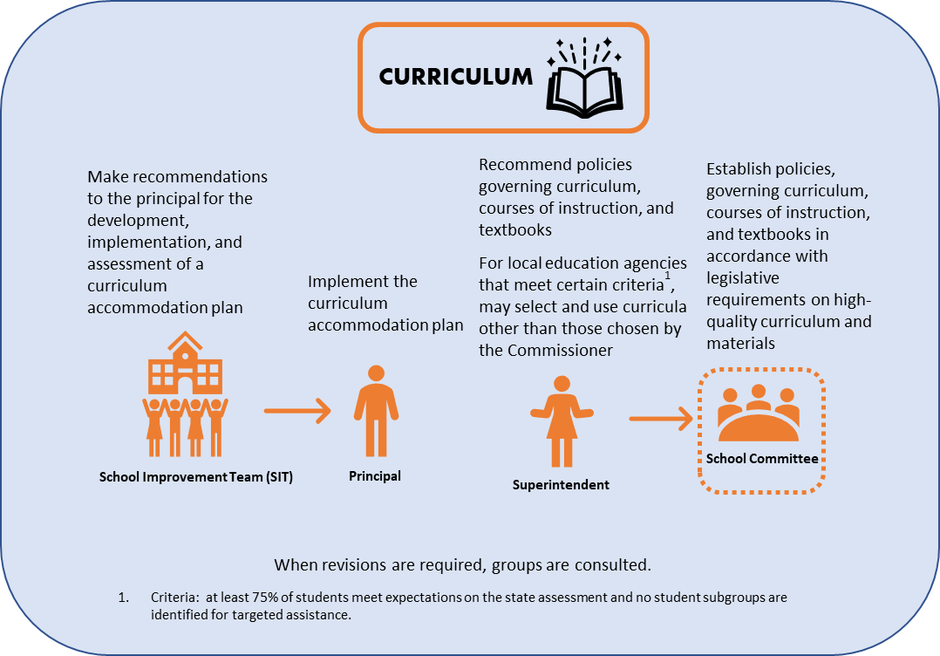

Curriculum

Curriculum
ACCOMODATION
plan

Note. The final decision regarding curricula rests with the school committee, as indicated by the dashed line. For more information on the legislative requirements on high-quality curriculum see S0863.
Figure 2. Duties of key policymakers regarding a school improvement plan
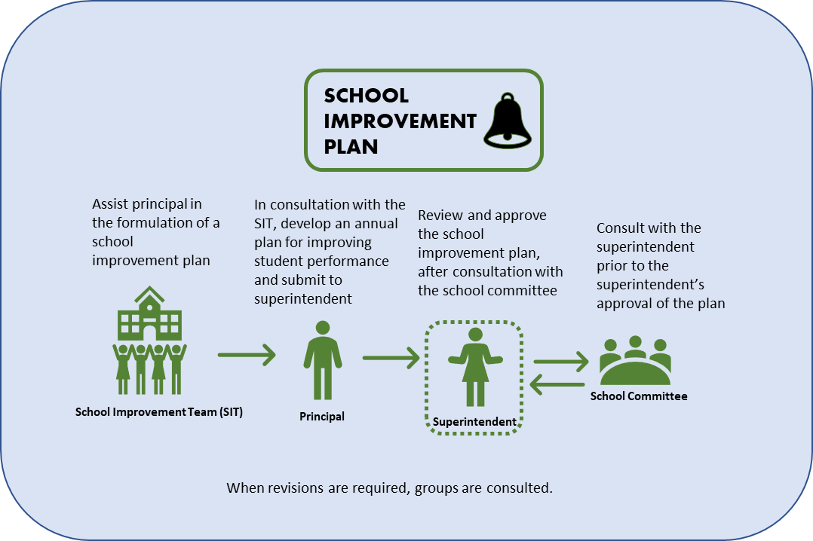

Note. The final decision regarding the school improvement plan rests with the superintendent as indicated by the dashed line.
Figure 3. Duties of key policymakers regarding a school budget
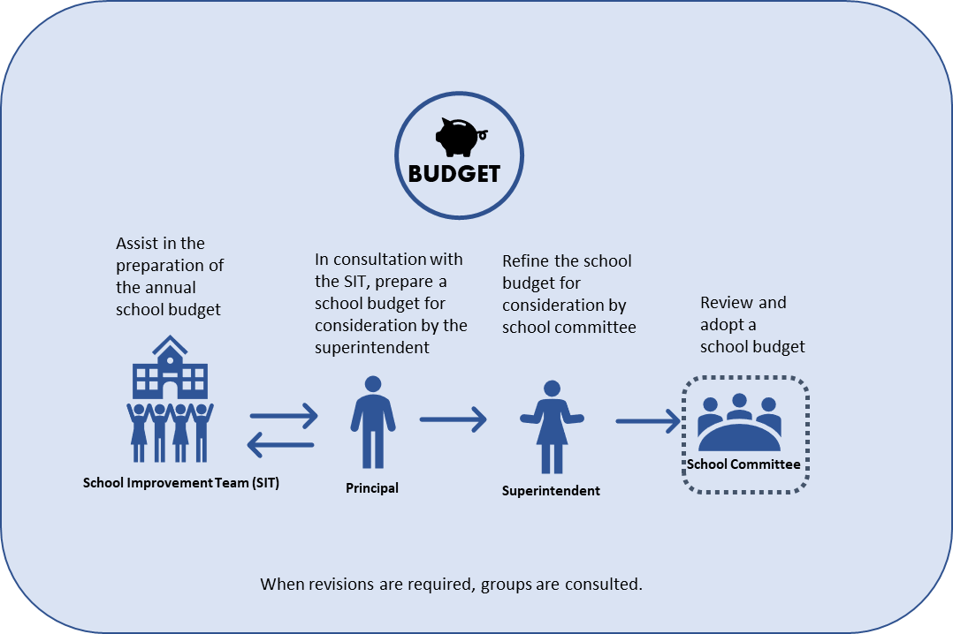

Note. The final decision regarding a school budget rests with the school committee as indicated by the dashed line.
Figure 4. Duties of key policymakers regarding hiring/termination of school personnel

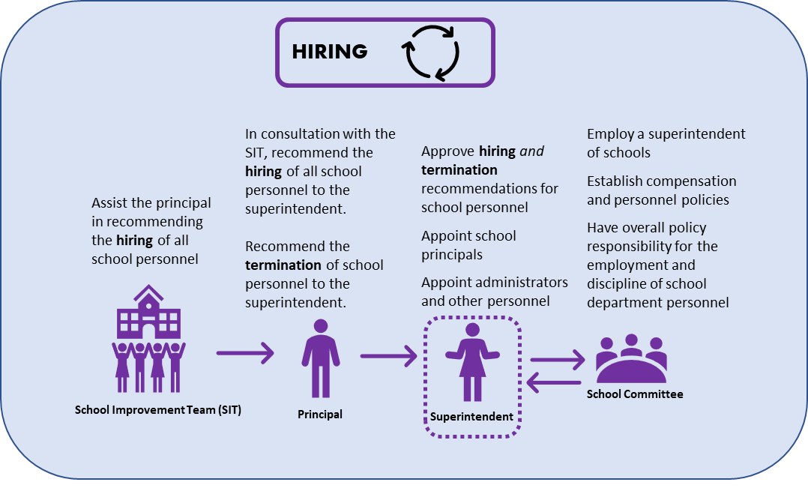
Note: The final decision regarding hiring and termination rests with the superintendent as indicated by the dashed line.

Summary
SITs are a powerful strategy to support school change efforts. In Rhode Island, SITs are designed to include representation from educators, students, families, and community partners. This inclusive design ensures that diverse perspectives are voiced as key decisions are contemplated, and increases the likelihood that initiatives will be supported and implemented as designed.
Using this guidance, local education agency and school leaders in Rhode Island will be equipped with the information that they need in order to adhere to legislative requirements regarding the composition and duties of SITs. Moreover, leaders will be able to make informed decisions about how to structure and continuously improve SITs to maximize the effectiveness of SIT meetings as levers for change. For additional information on SITs, please contact SchoolImprovement@ride.ri.gov at the Rhode Island Department of Education.

Appendix
Table A1. Shifts in the duties of SITs resulting from the Education Accountability Act of 2019
 | Pre-Act | Additions from the Act
Duties of School Improvement Teams (SIT) | Text no longer included in law:  Each SIT shall perform any functions that are prescribed by regulations of the school committee; no SIT shall have any of the powers and duties now reserved by law to the school committee.  Each SIT shall assist in the preparation and evaluation of the school improvement plans and shall provide any assistance that the Principal may request in preparing the school’s annual budget and plan as required by law. | Assist in the identification of the educational needs of the students attending the school.  Make recommendations to the principal for the development, implementation and assessment of a curriculum accommodation plan.  Assist in the formulation of a school improvement plan.  Assist in the preparation of the annual school budget.  Assist the principal in recommending the hiring of all teachers, athletic coaches, instructional or administrative aides, and other personnel assigned to the school.

Table A2. Duties of policy actors
Policy Actor | Duties & Responsibilities per the Education Accountability Act of 2019
Principal | - Oversee care, control and management of facilities and equipment.  - In consultation with the SIT, prepare a school budget for consideration by the Superintendent.  - In consultation with the SIT, recommend the hiring of all teachers, athletic coaches, instructional or administrative aides, and other personnel assigned to the school, consistent with district personnel policies, collective bargaining agreements, and budgetary restrictions, and subject to the approval of the Superintendent.  - Recommend the termination of any teachers, athletic coaches, instructional or administrative aides, and other personnel assigned to the school, consistent with district personnel policies, collective bargaining agreements and budgetary restrictions, subject to review and prior approval by the superintendent and subject to the provisions of this chapter.  - Provide for the evaluation of personnel assigned to the school, including all teachers, consistent with the standards developed by the school committee.  - In cooperation with the district’s leadership, initiate a performance review plan for the school and for individual teachers.  - In consultation with professional staff of the building, promote participatory decision-making among all professional staff for the purpose of developing educational policy.  - In consultation with the SIT, shall annually develop and submit to the district Superintendent a plan for improving student performance.
Superintendent | - Review and approve the school improvement plan, after consultation with the school committee  - Implement policies established by the school committee.  - Recommend educational plans, policies, and programs to meet the needs of the district.  - Recommend policies governing curriculum, courses of instruction, textbooks, and transportation of students.  - Comply with provisions of federal and state law and local charter provisions and ordinances.  - Have administrative responsibility for the school system.  - Appoint principals for each public school within the district at levels of compensation determined in accordance with policies established by the school committee.  - Appoint administrators and other personnel not assigned to individual schools. Also, to appoint, at the recommendation of the principal, personnel at individual schools in accordance with policies established by school district policies and collective bargaining agreements.  - Oversee the personnel function of the school department consistent with personnel standards, policies, and the table of organization established by the school committee.  - Provide for the evaluation of department personnel appointed by the superintendent.  - Prepare a school budget for consideration by the school committee.  - Authorize purchases consistent with the adopted school budget, policies and directives of the school committee, and applicable municipal policies, ordinances, and charter provisions.  - Be responsible for keeping the records of the school system.  - Report to the school committee on a regular basis the financial condition of the school system.  - Oversee discipline in the school system.  - Evaluate all schools within the school system and to report to the school committee the conformity with regulations of the board of regents and the policies, programs, and directives of the school committee.  - Report to the school committee on the operation of the school system, including an annual report on the district’s progress.
School Committee | - Identify educational needs in the community.  - Develop education policies to meet the needs of the community.  - Provide for and assure the implementation of federal and state laws, the regulations of the board of regents for elementary and secondary education, and of local school policies, programs, and directives.  - Provide for the evaluation of the performance of the school system.  - Have responsibility for the care and control of local schools.  - Have overall policy responsibility for the employment and discipline of school department personnel.  - Approve a master plan defining goals and objectives of the school system. These goals and objectives shall be expressed in terms of what men and women should know and be able to do as a result of their educational experience. The committee shall periodically evaluate the efforts and results of education in light of these objectives.  - Provide for the location, care, control, and management of school facilities and equipment.  - Enter into contracts.  Staff Hiring and Dismissals  - Employ a superintendent of schools and assign any compensation and other terms and conditions as the school committee and superintendent shall agree, provided that in no event shall the term of employment of the superintendent exceed three (3) years.  - Establish minimum standards for personnel, to adopt personnel policies, and to approve a table of organization.  - Establish standards for the evaluation of personnel.  - Establish standards for conduct in the schools and for disciplinary actions.  - Hear appeals from disciplinary actions.  - Publish policy manuals which shall include all school committee policies.  - Delegate, consistent with law, any responsibilities to the superintendent as the committee may deem appropriate.  Staff Configuration and Assignments  - Establish a school improvement team for each school in the district, and develop procedures for the election and appointment of school improvement team members.  - Review the membership composition of each school improvement team… appoint additional members to achieve proper representation.  - May establish a district school improvement team…  Budget  - Adopt a school budget to submit to the local appropriating authority.  - Adopt any changes in the school budget during the course of the school year.  - Approve expenditures in the absence of a budget, consistent with state law.  - Maintain a school budget which does not result in a debt.  - Within thirty (30) days after the close of the first and second quarters of the state’s fiscal year, adopt a budget as may be necessary to enable it to operate without incurring a debt, as described in subsection (d) of the Education Accountability Act of 2019.  - In the event that any obligation, encumbrance, or expenditure by a superintendent of schools or a school committee is in excess of the amount budgeted or that any revenue is less than the amount budgeted, the school committee shall within five (5) working days of its discovery of potential or actual over expenditure or revenue deficiency submit a written statement of the amount of and cause for the over obligation or over expenditure or revenue deficiency to the city or town council president and any other person who by local charter or statute serves as the city or town’s executive officer; the statement shall further include a statement of the school committee’s plan for corrective actions necessary to meet the requirements of subsection (d). The plan shall be approved by the auditor general and also submitted to the division of municipal finance.  Curriculum  - Establish policies governing curriculum, courses of instruction, and text books.  Academic & Non- Academic Supports & Services  - Address the health and wellness of students and employees.  - Establish a subcommittee of the school board or committee to decrease obesity and address school health and wellness policies for students and employees.  - Provide for transportation services which meet or exceed standards of the board of regents for elementary and secondary education.  Other  - Make any reports to the department of education as are required by the board of regents for elementary and secondary education.  - Annually undertake a minimum of six (6) hours of professional development.  - Notwithstanding any other provision of law, whether of general or specific application, and notwithstanding any contrary provision of any city or town charter or ordinance, the elected school committee of any city, town and regional school district shall be, and is hereby authorized to retain the services of such independent legal counsel as it may deem necessary and convenient. Any counsel so retained shall be compensated out of funds duly appropriated to the school committee, and in no event shall the independent counsel be deemed to be an employee of the pertinent city or town for any purpose.  - The elected school committees of each city, town, or regional school district, or the chief executive officer of any municipality having an appointed school committee, shall have the power to bind their successors and successor committees by entering into contracts of employment in the exercise of their governmental functions.

Table A3. Roles of policy actors by topic area
Policy Actors |  |  |  |  |  | Overview
C | SC | S | P | SIT
Legend:
C=Commissioner, SC=School Committee, S=Superintendent, P=Principal, SIT=School Improvement Team
I=Input, D=Decision, A=Approval, FA=Final Approval, G=Guidance-Setting
ACADEMIC & NON-ACADEMIC SUPPORTS & SERVICES
 |  | A | D |  | I | The SIT and the P shall meet regularly and shall assist in the identification of the educational needs of the students attending the school; make recommendations to the P for the development, implementation, and assessment of a curriculum accommodation plan; and assist in the formulation of a school improvement plan. If the S does not approve the plan, the P and the SIT will revise the plan.
BUDGET
 | FA | A | D |  | I | In the Education Accountability Act of 2019 (EAA), the P is granted responsibility for preparation of the budget after a review of the annual school budget with the SIT, and in consultation with the SIT. To ensure that stakeholders on the SIT have had input, the SC may establish a SIT and develop procedures for the election and appointment of SIT members.
CURRICULUM
G |  | D |  |  |  | Pursuant to RIGL§ 16.22.30-33, the C identifies at least five examples of high-quality curriculum for math, ELA, science and technology, and directs all S (LEAs) to select one of the identified high-quality curricula and materials. Earned Autonomy: Any S (LEA) that has at least 75% of its students meeting expectations on statewide assessments, and that also has no student subgroup identified for targeted assistance, may select and use curricula and materials other than those selected by the C.
EVALUATIONS & PERFORMANCE REVIEWS
 | G | I, D | D |  |  | The S will be responsible for the evaluation of department personnel appointed by the S.  The P will conduct evaluations, consistent with the standards developed by the SC.  With district leadership, Ps will develop performance review plans for the school and for individual teachers.
INSTRUCTION
 | G |  | D |  | I | The S recommends educational plans, policies, and programs to meet the needs of the district and policies governing curriculum, courses of instruction, textbooks, and transportation of students. The SC establishes policies governing curriculum, courses of instruction, and textbooks. The C recommends to the board an outline of the subjects and courses of study and the instructional standards for elementary and secondary schools. The SIT makes recommendations to the P for the development, implementation, and assessment of a curriculum accommodation plan.
PROFESSIONAL DEVELOPMENT
G |  |  |  |  |  | Each year, the C prepares a plan for providing statewide assistance in the preparation and implementation of professional development plans. No further guidance is provided within the law.
SCHEDULING
G |  | A | D |  |  | In the EAA, the C recommends the basic subjects and courses of study to be taught and the instructional standards to be maintained in the public elementary and secondary schools in the state. The P retains control of scheduling, under the direction of the S.
STAFF CONFIGURATIONS & ASSIGNMENTS
 | G | D |  |  |  | The S oversees the personnel function of the school department, consistent with personnel standards, policies, and the table of organization established by the SC.
STAFF HIRING & DISMISSALS
 |  | A | D |  | I | In consultation with the SIT, the P recommends the hiring and termination of school-based staff, consistent with district personnel policies, collective bargaining agreements, and budgetary restrictions, and subject to approval of the S.

Benoliel, P. & Berkovich, I. (2017). There is no “T” in school improvement: the missing team perspective. International Journal of Educational Management, 31(7) pp. 922-929. Retrieved from https://www.emerald.com/insight/content/doi/10.1108/IJEM-04-2016-0069/full/html.
Ibid.
Hanover - [add citation] https://www.hanoverresearch.com/media/Best-Practices-for-School-Improvement-Planning.pdf
School Improvement Planning: A Handbook,” Op. cit.
For the purposes of SITs, “teacher” includes classroom teachers, certified student services personnel, and media specialists.
Education support employee refers to any person employed by a school who is not defined as an instructional or administrative personnel and whose duties require twenty or more hours per week.
At the middle and high school levels, where there are designated department heads, they must be included on the SIT. At a minimum, there should be at least one department head from a humanities subject area and at least one department head from a STEM subject area. This is a new addition per the 2019 Education Accountability Act.
Vocational-technical centers and high school SITs must include students, while middle and junior high school SITS may include students.
Principal duties with respect to SITs, as well as other duties explicitly referenced in the Education Accountability Act of 2019, are articulated in Table A2 in Appendix A.

